Case 19-AM,C-Taino-Theriomorphic Frog Body Stamp-1200-1450

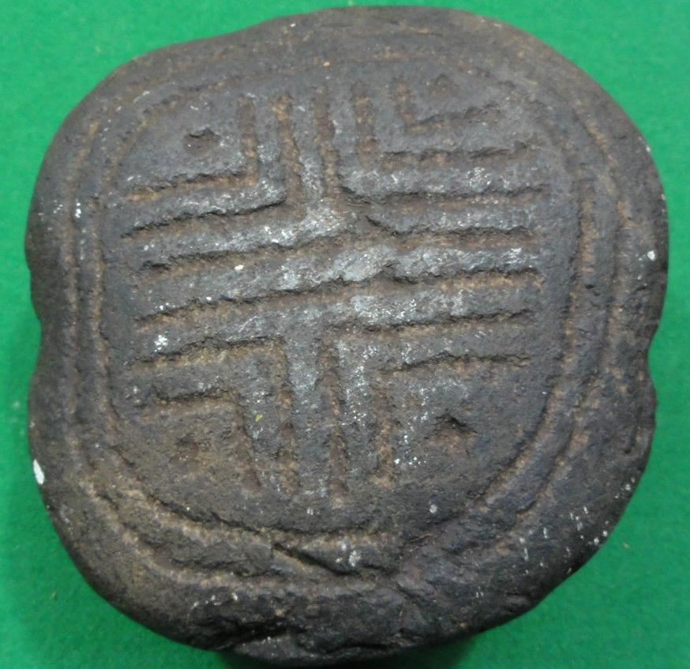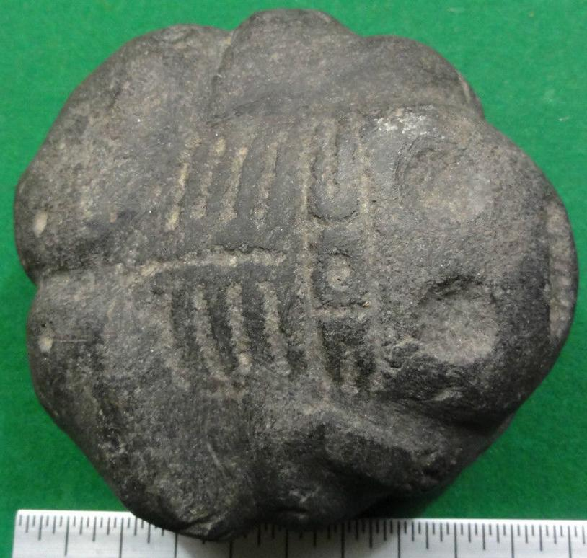

Taino Frog Body-stamp Cemi. Atlantika collection

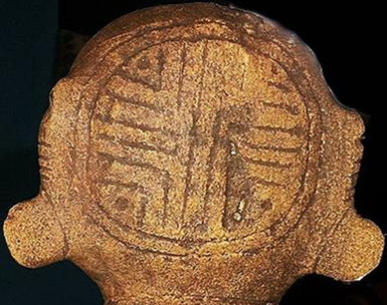

Itiba Cahubaba’s Head Matrix. the sculpture of *Itiba Cahubaba* is the ancestress of humanity indicated by the symbolism of her encircled navel that shows that she is the Taino symbol of life itself. The red dots may indicate the four quarters of the year and the green dots may indicate the four periods as a conjunction of the male and female principles when it us permissible to seek a pregnancy. Note the male principles are solid lines that are approximately diameters of the circle indicating male fertility s year-round. The female principles are quarterly as roughly the radius of the circle. The circle is the yearly round of seasons. An earlier attempt at limiting fertility rates.







Taino Frog stamp matrix. Atlantica collection. The red dots may indicate the four quarters of the year and the green dots may indicate the four periods as a conjunction of the male and female principles when it us permissible to seek a pregnancy. Note the male principles are solid lines that are approximately diameters of the circle indicating male fertility s year-round. The female principles are quarterly as roughly the radius of the circle. The circle is the yearly round of seasons. A later attempt at limiting fertility rates.

The frog is a well-known Tainó symbol of fertility, and women were thought to become especially fertile when frogs emerged from tadpoles. Here, in this sculpture, we have evidence of the connection between *Itiba Cahubaba* and frog symbolism. Since the emergence of the frog from tadpoles occurred only once a year, the myth could have the effect of proscribing successful human fertilization to once a year. If this hypothesis is correct, then it is possible that shamans in the instruction of male and female youth’s puberty rites may have given some kind of birth control guidance to both sexes.

This hypothesis is supported by the fact that that shamans gave instruction to pubescent girls in unlocking sexual experience by using puberty rite stones in the shape of circumcised penises to rupture the hymen (Olsen 1974: 348). The exact shape of the puberty rite stone also indicates that it involved the cutting of the foreskin. Therefore, both puberty rites involved uninitiated youth in a spiritually consented, common ritual that was sealed in blood by shamans in the service of the whole community, in order to protect future generations from over-populating their precious, limited insular resources. This spiritual-sexual practice aligned human fertility and its associated liquid component, blood, with the fertility of the land and its liquid component, rain, and the liquid component of rivers and the sea, water, with the fertility of the island’s natural resources.

**References**

Alegría, R.E. 1981. *El uso de la terminologìa etnohistòrica para designar ias culturas aborigenes de las Antillas*. Valladolid:Seminario Historia de América, Universidad de Valladolid.

Alegría, R.E. 1986. *Apuntes en torno a la mitologo de los Indios Taños de las Antillas Mayores y sus argenes Suramericanos*.San Juan: Centro de Estudios Avanzados de Puerto Rico y el Caribe.

Allaire, L. 1977. Later Prehistory in Martinique and the island Caribs: problems in *ethnic identification*. Ph.D. dissertation, Yale University. Ann Arbor: University Microfilms.

Allaire, L. 1980. On the historicity of Carib migrations in the Lesser Antilles, *American Antiquity* **45**: 238–45. |

Cosculluela, J. A. 1946. Prehistoric cultures of Cuba, *American Antiquity* **12**: 10–18. |

Craton, M. 1986. *A history of the Bahamas*. Waterloo, Canada: San Salvador Press. 3rd edition.

Davis, D.D. & Goodwin, R.C.. In press. *Island Carib origins: evidence and non-evidence*, American Antiquity 54.

Fewkes, J.W. 1907. *The aborigines of Porto Rico and neighboring islands*. Washington (DC): U.S. Government Printing Office. Twenty-fifth Annual Report of the U.S. Bureau of American Ethnology, 1903–1904.

Fox, R. 1967. *Kinship & marriage*. New York: Cambridge University Press.

Cranberry, J. 1987. Antillean languages and the aboriginal settlement of the Bahamas: a working hypothesis. *Paper presented at the conference Bahamas 1492: its people and environment, Freeport, Bahamas*, November 13–18 1987.

Harrington, M.R. 1921. Cuba before Columbus, *Indian Notes and Monographs* vols. **1, 2**. New York: Museum of the American Indian, Heye Foundation.

Keegan, W.F. 1985. Dynamic horticulturalists: population expansion in the prehistoric Bahamas. Ph.D. dissertation,*UCLA*. Ann Arbor: University Microfilms.

Keegan, W.F. 1987a. Diffusion of maize from South America: the Antillean connection reconstructed, in Keegan, W.F.(ed.), *Emergent horticultural economies of the eastern woodlands:* 329–44. Carbondale (IL): Southern Illinois University, Center for Archaeological Investigations. Occasional Paper 7.

Keegan, W.F. 1987b. Structural determinants of Lucayan Taino settlement patterns. Paper presented at the 52nd. annual meeting of the Society for American Archaeology, Toronto.

Keegan, W.F. & Maclachlan, M.D.. In press. The evolution of avunculocal chiefdoms: a reconstruction of Taino kinship and politics, *American Anthropologist* **91**.

Keesing, R.M. 1975. *Kin groups and social structure*. New York: Holt, Rinehart & Winston.

Loven, S. 1935. *Origins of the Tainan culture, West Indies*. Goteborg: Elanders Bokfryckeri Akfiebolag.

Marquardt, W.H. 1987. South Florida contacts with the Bahamas: a review and some speculations. *Paper presented at the conference Bahamas* **1492**: its people and environment, Freeport, Bahamas, November 13–18 1987.

Moore, C. 1982. Investigation of preceramic sites on Ile à Vache, *Haiti, The Florida Anthropologist* **35**: 186–99.

Murdock, G.P. 1949. *Social structure*. New York: Macmillan.

Myers, R.A. 1984. Island Carib cannibalism, *Nieuwe West-Indische Gids* **58**: 147–84. |

Olsen, F. 1974. *On the trail of the Arawaks*. Norman: University of Oklahoma Press.

Osgood, C. 1942. *The Ciboney culture of Cayo Redondo, Cuba*. New Haven (CT): Yale University Publications in Anthropology 25.

Rouse, I. 1948. The West Indies, in Steward, J.H. (ed.), *Handbook of South American Indians* **4**: the Circum-Caribbean tribes: 507–46. Washington (DC): Bureau of American Ethnology. *Bulletin* **143**(4).

Rouse, I. 1960. *The entry of man into the West Indies*. New Haven (CT): Yale University Publications in Anthropology 61.

Rouse, I. 1986. *Migrations in prehistory*. New Haven: Yale University Press.

Rouse, I. 1987. Whom did Columbus discover in the West Indies?, *American Archaeology* **6**: 85–7.

Rouse, I. & Allaire, L.. 1978. Caribbean, in Taylor, R.E. & Meighan, C. (ed.), *Chronologies in New World archaeology:* 431–81. New York: Academic Press.

Sauer, CO. 1966. *The early Spanish Main*. Berkeley (CA): University of California Press.

Sears, W.H. & Sullivan, S.D.. 1978. Bahamas prehistory, *American Antiquity* **43**: 3–25. |

Stuiver, M. & Reimer, P.J.. 1986. A computer program for radiocarbon age calibration, *Radiocarbon* **28**:1022–30. |

Sturtevant, W.C. 1960. The significance of ethnological similarities between southeastern North America and the Antilles. New Haven: Yale University Publications in Anthropology 64.

Sturtevant, W.C. 1961. Taino agriculture, in The evolution of horticultural systems in native South America: causes and consequences - a symposium, *Anthropologica (Supl. 2)*: 69–73.

Sued-Badillo, J. 1978. *Los Caribes: realidad o fabula*. Ro Piedras (PR): Editorial Antillana.

Sued-Badillo, J. 1979. *La mujer indgena y su sociedad*. Rio Piedras (PR): Editorial Antillana. 2nd edition.

Tabio, E.E. & Rey, E.. 1979. *Prehistoria de Cuba*. Habana: Editorial de Ciencias Sociales.

Wilson, S.M. 1986. *The conquest of the Caribbean chiefdoms*. Ph.D dissertation, University of Chicago.